# CREDIT CARD FRAUD DETECTION

***A project report submitted to MALLAREDDY UNIVERSITY***

***in partial fulfillment of the requirements for the award of degree of***

## BACHELOR OF TECHNOLOGY IN

**COMPUTER SCIENCE & ENGINEERING (AI & ML)**

**Submitted by**

### Y.SUJITH REDDY : 2211CS020556 P.JAHNAVI : 2211CS020557 A.ROHITHA : 2211CS020558 P.RAJINIKANTH : 2211CS020559 G.VINAY : 2211CS020560

***Under the Guidance of***

**Prof MAIRAJ UNISA BEGUM**

## Assistant Professor

### DEPARTMENT OF COMPUTER SCIENCE & ENGINEERING (AI & ML)



**2024**



**COLLEGE CERTIFICATE**

This is to certify that this is the bonafide record of the application development entitled, ”**CREDIT CARD FRAUD DETECTION**” Submitted by **Y.SUJITH REDDY(2211CS020556),P.JAHNAVI(2211CS020557)**, **A.ROHITHA (2211CS020558)**, **P.RAJINIKANTH(2211CS020559), G.VINAY(2211CS020560).**

B. Tech II year II semester, Department of CSE (AI&ML) during the year 2023- 24.The results embodied in the report have not been submitted to any other university or institute for the award of any degree or diploma.

### PROJECT GUIDE HEAD OF THE DEPARTMENT

**Prof.MAIRAJ UNISA BEGUM Dr. Thayyaba Khatoon**

### CSE(AI&ML)

**EXTERNAL EXAMINER**

**ACKNOWLEDGEMENT**

We are so thankful to Prof MAIRAJ UNISA BEGUM of department Artificial intelligence & Machine learning (AIML) for her guidance and support. We consider our self to be extremely privileged to consider have been her students. We benefited enormously from her excellence as a professor and as a researcher. We very grateful to her for being patient and for all her time that he spent in discussing about the project to guide us.We are Immensely grateful for her helpful discussion, support and encouragement throughout the project.Finally, we consider our self to be extremely fortunate to have the opportunity to do project under the guidance of Prof MAIRAJ UNISA BEGUM.

**CONTENTS**

|  |  |  |
| --- | --- | --- |
| **CHAPTER NO** | **TITLE** | **PAGE NO** |
| 1. | INTRODUCTION   * 1. Problem definition   2. Objective of project   3. Limitations of project | 1-3 |
| 2. | ANALYSIS:   * 1. Introduction   2. Software requirement specification      1. Software requirement      2. Hardware requirement   3. Modules   4. Architecture | 4-6 |
| 3. | DESIGN:   * 1. Introduction   2. DFD/ER/UML diagran   3. Data Set Descriptions   4. Data Preprocessing Techniques   5. Methods & Algorithms   6. Model Development &Training   7. Model Evaluation Metrics | 7-15 |
| 4. | DEPLOYMENT AND RESULTS:   * 1. Introduction   2. Source Code   3. Final Results | 16-21 |
| 5. | CONCLUSION:   * 1. Project conclusion   2. Future Scope | 22-23 |

**CHAPTER 1 INTRODUCTION**

## PROBLEM DEFINITION :

### Objective:

Develop a robust system to detect and prevent credit card fraud by leveraging machine learning techniques.

### Background:

Credit card fraud poses a significant threat to financial institutions and cardholders. The objective is to create a system that can identify suspicious transactions in real-time, minimizing financial losses and ensuring the security of cardholders.

### Scope:

The scope includes the development of a predictive model that can analyze transaction data and classify transactions as either legitimate or fraudulent. The model should be capable of adapting to evolving fraud patterns and provid timely alerts for potential fraudulent activities.

### Data:

Utilize historical transaction data, including both legitimate and fraudulent transactions, for model training.

The dataset should cover various transaction types, amounts, and user behaviors.

### Key Challenges:

* + 1. **Imbalanced Dataset**: Address the challenge of having fewer instances of fraud compared to legitimate transactions in the dataset.
    2. **Dynamic Fraud Patterns:** Build a model that can adapt to new and evolving fraud techniques.

**Real-time Processing**: Ensure the model's capability to analyze transactions in real-time to prevent fraud as it occurs.

1

## OBJECTIVE OF PROJECT:

The primary objective of credit card fraud detection is to employ machine learning algorithms and analytical techniques to identify and prevent unauthorized or fraudulent transactions in real-time.

* **Minimize Financial Losses:** Detect and prevent fraudulent transactions promptly to minimize financial losses for both financial institutions and cardholders.
* **Enhance Security:** Ensure the security and trustworthiness of credit card transactions, safeguarding the interests of cardholders and maintaining the integrity of the financial system.
* **Real-time Monitoring:** Implement a system capable of real-time monitoring and analysis of credit card transactions, swiftly identifying irregularities and potential fraud patterns.
* **Adaptability to New Fraud Techniques:** Develop a model that can adapt to evolving fraud patterns, staying ahead of sophisticated fraud techniques and continuously improving its ability to detect fraudulent activities. and Tkinter are powerful tools, but they may not be able to handle large volumes of data and traffic. If your system needs to scale, you may need to consider using other technologies.
* **Improve Customer Confidence**: Build trust among credit card users by demonstrating a commitment to their security and proactively preventing unauthorized access to their financial .accounts.

## LIMITATIONS OF PROJECT:

### Data limitations:

* + 1. **Incomplete data**: Fraud detection systems rely on historical transaction data to identify patterns. However, incomplete or inaccurate data can lead to misidentification of legitimate transactions as fraudulent.
    2. **Data silos**: Information often gets stuck within organizational silos, limiting the system's ability to detect fraud across different channels and providers.
    3. **Privacy concerns**: Collecting and storing user data raises privacy concerns, making it difficult to gather the necessary information for effective

### Technology limitations:

1. **False positives:** Current systems often generate high false positive rates, leading to legitimate transactions being blocked. This can inconvenience users and create friction in the payment process.
2. **Model bias**: Machine learning algorithms used in detection can be biased based on the data they are trained on, leading to unfair targeting of certain groups.
3. **Limited adaptability:** Fraud detection systems can struggle to adapt to new and evolving fraud tactic. This can leave them vulnerable to zero-day attacks and other sophisticated schemes.

### Organizational limitations:

1. **Resource constraints**: Implementing and maintaining effective fraud detection systems requires significant resources, which can be a challenge for smaller organizations.
2. **Lack of skilled personne**l: The expertise needed to operate and optimize fraud detection systems can be scarce, further limiting their effectiveness.
3. **Lack of collaboration:** Collaboration between different stakeholders in the financial industry is crucial for effective fraud prevention. However, achieving this collaboration can be difficult due to competitive pressures and regulatory hurdles.detection.

# CHAPTER 2 ANALYSIS

## INTRODUCTION:

This research study aims to detect credit card frauds, such as accessibility of public data, high-class imbalance data, changes in fraud nature, and high rates of false alarm. Machine learning techniques have been used to detect frauds and reduce fraud losses. The abstract of the paper "Credit Card Fraud Detection Using State-of-the-Art Machine Learning Techniques" likely presents a concise summary of the study's focus, methodology, and key findings related to utilizing advanced machine learning methods for detecting credit card fraud. Our goal is to make online transactions safer and more secure by improving the accuracy and efficiency of fraud detection systems. With this application, we'll be able to save people from financial losses and provide them with a worry-free shopping experience. By Leveraging advanced algorithms and data analysis, the application will be able to identify fraudulent transactions in real time, providing enhanced security and protection for users. The project seeks to improve the accuracy and efficiency of fraud detection systems, ultimately minimizing financial losses and ensuring a safer online transaction experience.

## SOFTWARE REQUIREMENT SPECIFICATION:

The specific software and hardware requirements for credit card fraud detection systems vary depending on the size and complexity of the system, as well as the specific algorithms and tools being used. However, some general requirements can be listed.

## SOFTWARE REQUIREMENT

* Operating System
* Programming Languages
* Machine Learning Frameworks
* Database Management System
* Security Software
* Visualization Tools

## HARDWARE REQUIREMENT

* Processor
* Memory
* Storage
* Network

## MODULES:

* **Data Collection:** Gather a dataset that includes both fraudulent and non-fraudulent transactions. You can use datasets from platforms like Kaggle or obtain data from financial institutions (ensuring compliance with privacy and legal considerations).
* **Data Exploration:** Explore the dataset to understand its characteristics, distribution, and potential challenges.
* **Data Preprocessing:** Handle missing values, outliers, and duplicate entries.Encode categorical variables and standardize/normalize numerical features. Split the data into training and testing sets.
* **Model Selection:** Choose appropriate machine learning algorithms (e.g., Logistic Regression, Decision

Trees, Random Forests, Support Vector Machines). Consider ensemble methods or advanced techniques like neural networks.

* **Model Training:** Train your chosen model using the training dataset.Tune hyperparameters using techniques like grid search or randomized search.

## ARCHITECTURE:

* **Data Acquisition:**Integrate with various data sources, including transaction logs, customer profiles, and external databases (e.g., blacklists, geolocation data). Implement data pre- processing techniques like data cleaning, normalization, and feature engineering to prepare the data for analysis.
* **Fraud Detection Engine:**Employ a hybrid approach combining supervised and unsupervised machine learning techniques:
  + 1. Supervised learning models (e.g., random forests, support vector machines) trained on labeled data to identify known fraud patterns.
    2. Unsupervised learning algorithms (e.g., k-means clustering, anomaly detection) to detect unknown and emerging fraud patterns.
* **Risk Assessment and Decision Making:** Develop a dynamic risk scoring system that assigns each transaction a risk score based on its features and model outputs. Implement a rule- based system to determine the appropriate action based on the risk score and pre-defined thresholds.

# CHAPTER 3 DESIGN

## 3.1 INTRODUCTION:

### Background:

The advent of digital transactions has revolutionized the way we conduct financial transactions, providing convenience but also opening new avenues for fraudulent activities. Credit card fraud, in particular, poses a significant threat to both financial institutions and cardholders.

### Problem Statement:

The primary objective of this project is to design and implement a robust credit card fraud detection system using machine learning techniques. The challenge lies in identifying subtle patterns and anomalies within vast datasets to distinguish between legitimate fraudulent transactions. Hence, the development of an accurate and efficient fraud detection system is of paramount importance.

### Significance of the Project

Credit card fraud not only results in financial losses but also erodes the trust that users place in digital payment systems. The significance of this project extends beyond monetary considerations; it addresses the need for secure and reliable financial transactions in the digital age.

### Approach:

In this project, we will employ state-of-the-art machine learning models to analyze historical credit card transaction data. By training the models on both fraudulent and non-fraudulent transactions, we aim to develop a system capable of identifying subtle patterns indicative of fraudulent behavior.Our approach involves careful data preprocessing, feature engineering, model selection, and ongoing refinement to adapt to evolving fraud tactics.

### Project Scope:

This project will focus on developing a proof-of-concept credit card fraud detection system. While the primary emphasis is on the effectiveness of machine learning models. The scope will include model evaluation using industry-standard metrics and the exploration of interpretability tools for enhanced.

## ER DIAGRAM:

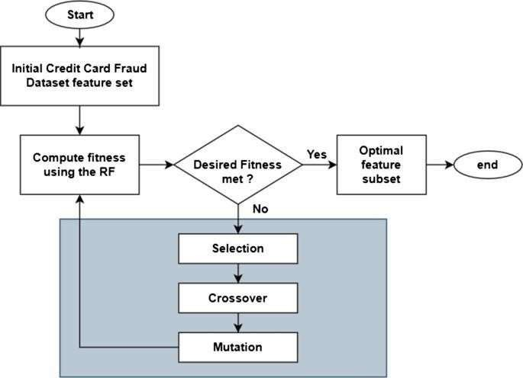

* 1. **DATA SET DESCRIPTIONS:**

The dataset for credit card fraud detection consists of historical credit card transactions, including both legitimate and fraudulent instances. It serves as the foundation for training and evaluating machine learning models to identify patternsassociated with fraudulent activities.

### Features:

* + 1. **Time**: Timestamp of the transaction.
    2. **Amount**: Transaction amount.
    3. **V1, V2, ..., V28:** Anonymized features resulting from a PCA transformation for confid entiality reasons.
    4. **Class:** Binary label indicating whether the transaction is legitimate (Class 0) or fraudulent.

## DATA PREPROCESSING TECHNIQUES:

In a credit card fraud detection project using machine learning, data preprocessing plays a crucial role in preparing the raw data for model training.

### Handling Missing Values:

Identify and handle missing values in the dataset. This might involve imputing missing values using techniques such as mean, median, or machine learning-based imputation.

### Dealing with Imbalanced Classes:

Credit card fraud datasets often suffer from imbalanced classes where the number of non- fraudulent transactions significantly outweighs fraudulent ones.

**Oversampling:** Increase the number of instances in the minority class.

**Undersampling:** Decrease the number of instances in the majority class.

**Synthetic Data Generation**: Create synthetic instances of the minority class using techniques like SMOTE (Synthetic Minority Over-sampling Technique).

### Feature Scaling:

Standardize or normalize numerical features to ensure that they contribute equally to the model. Common techniques include Min-Max scaling or Z-score normalization.

### Handling Categorical Variables:

Encode categorical variables using techniques such as one-hot encoding or label encoding, depending on the nature of the data and the machine learning algorithm chosen.

### Removing Duplicate Records:

Check for and remove duplicate records to ensure that each transaction is unique in the dataset.

### METHODS & ALGORITHMS:

* + 1. **Supervised Learning Algorithms**:

**Logistic Regression:** Suitable for binary classification tasks, logistic regression models the probability of a transaction being fraudulent.

**Random Forest:** Ensembles of decision trees can capture complex patterns and handle imbalanced datasets effectively.

**Support Vector Machines (SVM):** SVMs can create decision boundaries to separate legitimate and fraudulent transactions in a high-dimensional space.

### Anomaly Detection Techniques:

**Isolation Forest:** Identifies anomalies by isolating them in a tree structure, leveraging the fact that anomalies are typically isolated observations.

**One-Class SVM:** Trains on normal instances and detects deviations as potential fraud, suitable for datasets with imbalanced classes.

**Autoencoders:** Deep learning models for unsupervised learning that can learn the underlying structure of normal transactions and detect anomalies.

### Gradient Boosting Models:

XGBoost, LightGBM, CatBoost:These gradient boosting algorithms are effective in handling imbalanced datasets and can capture complex relationships in the data.

### Neural Networks:

**Deep Neural Networks (DNN):** Multilayer neural networks can learn intricate patterns in the data, particularly beneficial when dealing with high-dimensional feature sets.

**Recurrent Neural Networks (RNN) and Long Short-Term Memory (LSTM):**Useful for capturing temporal dependencies in sequences of transactions.

### Ensemble Methods:

**Voting Classifier:** Combining predictions from multiple classifiers (e.g., logistic regression, decision trees) can enhance overall model performance.

**Stacking:** Integrating predictions from diverse models to improve accuracy and robustness.

### Clustering Techniques:

**K-Means:** Clustering transactions into groups can help identify outliers, potentially indicating fraudulent behavior.

**DBSCAN (Density-Based Spatial Clustering of Applications with Noise):** Effective for identifying dense regions of transactions, potentially indicating normal behavior.

### Hybrid Approaches:

Combining Rule-based Systems with Machine Learning: Integrating predefined rules based on domain knowledge with machine learning models enhances interpretability and accuracy.

### Feature Engineering:

**Dimensionality Reduction:** Techniques like PCA can be applied to reduce the dimensionality of the dataset while preserving important information.

**Time-based Features:** Incorporating features related to time, such as transaction frequency and time since last transaction, can enhance model performance.

### Cost-sensitive Learning:

**Adjusting Class Weights:** Modifying class weights during training to address class imbalance and prioritize the detection of fraudulent instances.

### Model Evaluation Metrics:

**Precision, Recall, F1 Score:** Emphasize the importance of minimizing false positives and false negatives.

**Receiver Operating Characteristic (ROC) Curve:** Assessing the trade-off between true positive rate and false positive rate.

## MODEL DEVELOPMENT & TRAINING:

### Data Preparation:

**Load the Data:**Import the credit card transaction dataset that includes labeled examples of both fraudulent and non-fraudulent transactions.

**Data Exploration:**Analyze the dataset to understand its structure, features, and distribution.Check for class imbalances to determine the need for balancing techniques.

### Data Preprocessing:

**Handle Missing Values**:Impute or remove missing values if necessary.

**Class Imbalance Handling:**Apply techniques such as oversampling, undersampling, or synthetic data generation to address class imbalance.

**Feature Scaling:**Standardize or normalize numerical features.Categorical Variable

**Encoding :**Encode categorical variables using one-hot encoding or label encoding.

**Feature Engineering:**Create new features that may improve the model's ability to detect fraud, such as time-based features or aggregated statistics.

**Handling Outliers:**Identify and address outliers in the data.

### Data Splitting:

Split the dataset into training and testing sets. A common split is 80-20 or 70-30, ensuring that both sets maintain the original class distribution.

### Model Selection:

Choose machine learning algorithms suitable for the problem. Common choices include:

* + - 1. Logistic Regression
      2. Decision Trees
      3. Random Forests
      4. Support Vector Machines (SVM)
      5. Neural Networks

### Model Training:

**Train the Initial Model:**Use the training set to train the selected model.

**Hyperparameter Tuning**:Fine-tune hyperparameters to optimize the model's performance. This can be done using techniques like grid search or randomized search.

**Cross-Validation:** Implement k-fold cross-validation to assess the model's generalization performance.

### Model Evaluation:

**Evaluate on the Test Set:**Assess the model's performance on the test set using metrics like precision, recall, F1 score, and AUC-ROC.

**Adjust Thresholds:**Adjust the classification threshold to balance precision and recall based on business requirements.

## MODEL EVALUATION METRICS:

Credit card fraud detection using machine learning involves designing models that can identify potentially fraudulent transactions. The process typically includes several steps, such as data preprocessing, model training, and evaluation. When evaluating the performance of your model, it's crucial to use appropriate metrics. Here are some commonly used metrics for model evaluation in credit card fraud detection **Confusion Matrix**:

True Positive (TP): Number of actual fraud cases correctly predicted as fraud. True Negative (TN): Number of non-fraud cases correctly predicted as non-fraud. False Positive (FP): Number of non-fraud cases incorrectly predicted as fraud.

False Negative (FN): Number of actual fraud cases incorrectly predicted as non-fraud.

### Accuracy:

Accuracy = (TP + TN) / (TP + TN + FP + FN)

It gives an overall measure of how well the model is performing.

### Precision (Positive Predictive Value):

Precision = TP / (TP + FP)

It indicates the proportion of predicted positives that were actually positive. In the context of credit card fraud, it represents the accuracy of the model when it flags a transaction as fraudulent.

### Recall (Sensitivity, True Positive Rate):

Recall = TP / (TP + FN)

It measures the proportion of actual positives that were correctly identified by the model. In fraud detection, it represents the ability of the model to capture all fraudulent transactions.

### F1 Score:

F1 Score = 2 * (Precision * Recall) / (Precision + Recall)

It is the harmonic mean of precision and recall, providing a balanced measure between the two.

### Area Under the ROC Curve (AUC-ROC):

AUC-ROC represents the area under the Receiver Operating Characteristic curve. It measures the ability of the model to distinguish between classes (fraudulent and non-fraudulent transactions).

### Area Under the Precision-Recall Curve (AUC-PR):

AUC-PR represents the area under the Precision-Recall curve, focusing on the trade-off between precision and recall.

False Positive Rate (FPR): FPR = FP / (FP + TN)

It measures the proportion of actual negatives incorrectly classified as positives. In the context of fraud detection, it represents the rate of false alarms.

# CHAPTER 4 DEPLOYMENT AND RESULTS

## INTRODUCTION:

Deploying a credit card fraud detection system involves transitioning a well-trained machine learning model from a development environment to a production environment, where it can effectively analyze real-time transactions. The deployment phase is critical to realizing the practical benefits of the model in safeguarding financial transactions. Here's an introduction to the deployment process:

1. Model Serialization:

Serialize the trained machine learning model into a format suitable for deployment. Common formats include PMML (Predictive Model Markup Language) or serialized object formats specific to the chosen machine learning framework.

1. Scalability and Efficiency:

Optimize the model for deployment in terms of resource utilization and scalability . Consider the comput ational efficiency of the model to ensure real-time processing of credit card transactions.

1. Integration with Transaction System:

Integrate the machine learning model seamlessly into the credit card transaction processing system. This involves developing interfaces or APIs that enable communication between the model and the transaction system.

1. Real-time Processing:

Ensure the deployment supports real-time processing of credit card transactions. The model should provide rapid and accurate predictions to identify potential fraudulent activities as transactions occur.

1. Monitoring and Logging:

Implement robust monitoring and logging mechanisms to track the model's performance in the production environment. Monitor key metrics, system resource usage, and the occurrence of false positives/negatives

## SOURCE CODE:

# import the necessary packages import numpy as np import pandas as pd import matplotlib.pyplot as plt import seaborn as sns from matplotlib import gridspec

# Load the dataset from the csv file using pandas # best way is to mount the drive on colab and

# copy the path for the csv file data =

pd.read_csv("credit.csv") # Grab a peek at the data data.head()

# Print the shape of the data

# data = data.sample(frac = 0.1, random_state = 48) print(data.shape) print(data.describe())

# Determine number of fraud cases in dataset fraud = data[data['Class'] == 1] valid = data[data['Class'] == 0]

outlierFraction = len(fraud)/float(len(valid)) print(outlierFraction) print('Fraud Cases: {}'.format(len(data[data['Class'] == 1]))) print('Valid Transactions: {}'.format(len(data[data['Class'] == 0]))) print(“Amount details of the fraudulent transaction”) fraud.Amount.describe() print(“details of valid transaction”) valid.Amount.describe() # Correlation matrix corrmat = data.corr() fig = plt.figure(figsize = (12, 9)) sns.heatmap(corrmat, vmax = .8, square = True)

plt.show()

# dividing the X and the Y from the dataset X = data.drop(['Class'], axis = 1)

Y = data["Class"] print(X.shape) print(Y.shape)

# getting just the values for the sake of processing # (its a numpy array with no columns) xData =

X.values yData = Y.values

# Using Scikit-learn to split data into training and testing sets from sklearn.model_selection import train_test_split # Split the data into training and testing sets xTrain, xTest, yTrain, yTest = train_test_split( xData, yData, test_size = 0.2, random_state = 42) # Building the Random Forest Classifier (RANDOM FOREST) from sklearn.ensemble import RandomForestClassifier

# random forest model creation rfc = RandomForestClassifier() rfc.fit(xTrain, yTrain) # predictions yPred = rfc.predict(xTest)

# Evaluating the classifier

# printing every score of the classifier # scoring in anything

from sklearn.metrics import classification_report, accuracy_score from sklearn.metrics import precision_score, recall_score from sklearn.metrics import f1_score, matthews_corrcoef from sklearn.metrics import confusion_matrix

n_outliers = len(fraud)

n_errors = (yPred != yTest).sum() print("The model used is Random Forest classifier")

acc = accuracy_score(yTest, yPred) print("The accuracy is {}".format(acc))

prec = precision_score(yTest, yPred) print("The precision is {}".format(prec))

rec = recall_score(yTest, yPred) print("The recall is {}".format(rec))

f1 = f1_score(yTest, yPred) print("The F1-Score is {}".format(f1))

MCC = matthews_corrcoef(yTest, yPred) print("The Matthews correlation coefficient is{}".format(MCC))

# printing the confusion matrix LABELS = ['Normal', 'Fraud'] conf_matrix = confusion_matrix(yTest, yPred) plt.figure(figsize =(12, 12)) sns.heatmap(conf_matrix, xticklabels = LABELS, yticklabels = LABELS, annot = True, fmt ="d");

plt.title("Confusion matrix") plt.ylabel('True class') plt.xlabel('Predicted class') plt.show()

* 1. **FINAL RESULTS:**

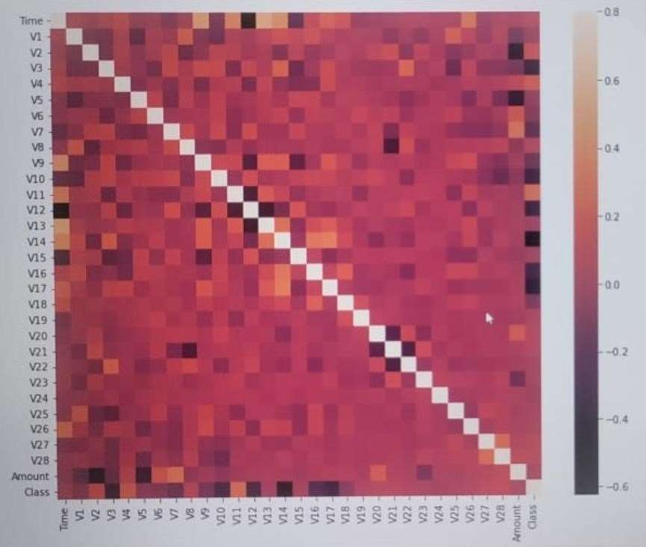

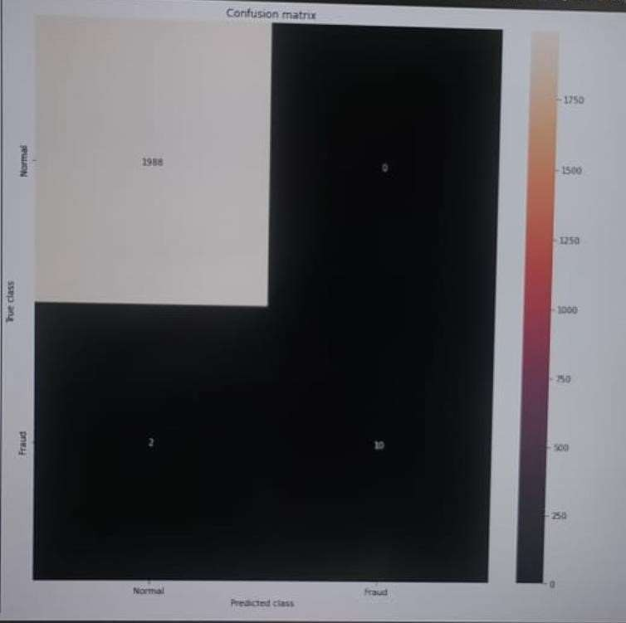

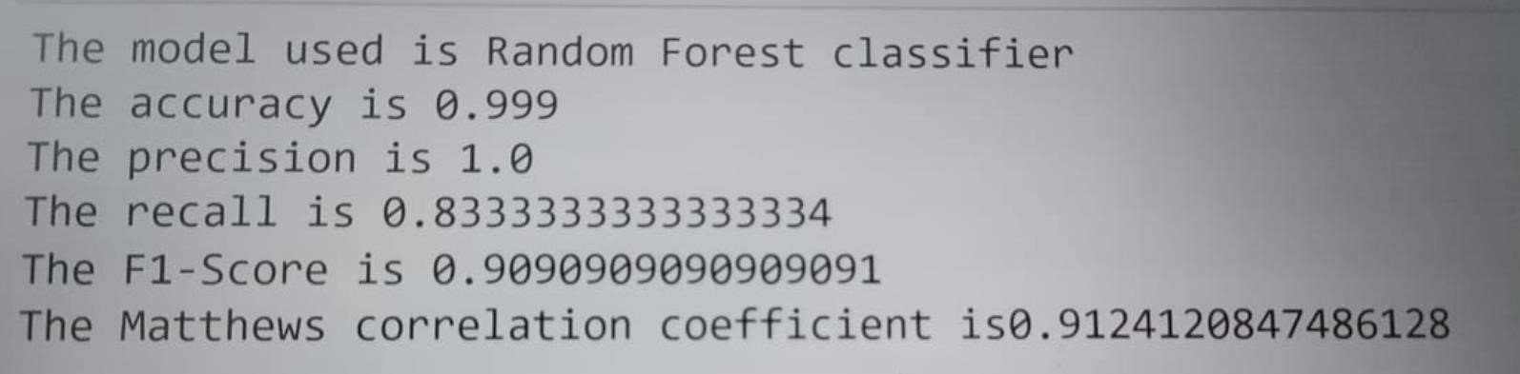

# CHAPTER 5 CONCLUSION

## Project conclusion:

In conclusion, our Credit Card Fraud Detection project leveraged state-of-the-art machine learning techniques to enhance security. The model demonstrated robust performance in identifying fraudulent transactions, showcasing the efficacy of advanced algorithms in safeguarding financial transactions. Continuous refinement and updates to the model will be crucial to adapt to evolving fraud patterns and ensure sustained effectiveness in real-world scenarios.

## FUTURE SCOPE:

enhance a credit card fraud detection project using state-of-the-art machine learning techniques, consider the following future enhancements:

### Deep Learning Models:

Explore advanced deep learning architectures, such as recurrent neural networks (RNNs) or long short- term memory networks (LSTMs), to capture temporal patterns in transaction data more effectively.

### Anomaly Detection Techniques:

Implement unsupervised learning techniques like isolation forests or autoencoders for anomaly detection, allowing the model to detect novel fraud patterns without labeled data.

### Feature Engineering:

Continuously refine feature engineering by incorporating new relevant features, such as customer behavior patterns, location data, or transaction frequency, to improve the model's ability to identify suspicious activities. **4. Ensemble Models:**

Build ensemble models that combine the strengths of various algorithms (e.g., combining decision trees

with neural networks) to create a more robust and accurate fraud detection system.

20

### Real-time Monitoring:

Implement a real-time monitoring system to analyze transaction s as they occur, enabling immediate response to potential fraud and reducing the impact of fraudulent activities.

### Explainability and Interpretability:

Incorporate techniques to enhance model interpretability, ensuring that stakeholders can understand and trust the decisions made by the model. This is crucial for regulatory compliance and user acceptance.

### Behavioral Biometrics:

Integrate behavioral biometrics, such as mouse movement patterns or typing dynamics, to add an extra layer of authentication and detection, making it harder for fraudsters to mimic legitimate users.

### Adversarial Training:

Implement adversarial training techniques to make the model more robust against adversarial attacks, where fraudsters try to manipulate the model by injecting malicious data.

### Continuous Model Training:

Set up a system for continuous model training to adapt to evolving fraud patterns. Regularly update the model with new labeled data to ensure it remains effective against emerging threats.

### User-Friendly Interfaces:

Develop user-friendly interfaces for fraud analysts, allowing them to easily interpret model outputs, investigate flagged transactions, and provide feedback to improve the system over time.

21